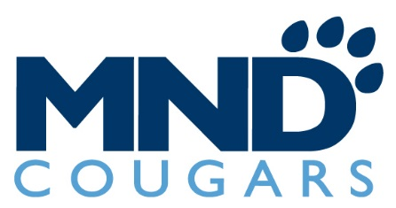

2021-2022 VARSITY BASKETBALL

# | Name | Grade | Height
00 | Laila Harrison | SO | 6’2”
2 | Bailey Broughton | SR | 5’9”
3 | Brittany Campbell | SO | 5’1”
4 | Abby Wolterman | SR | 6’0”
5 | Kailee Bransford | FR | 5’6”
10 | Sarah Hofmann | SO | 5’8”
11 | Avery Boland | SO | 5’8”
12 | Crysta LaCrosse | SR | 5’7”
14 | KK Bransford | SR | 5’11”
23 | Izzy Higgins | SO | 5’9”
24 | Maya Corsmo | SO | 5’8”
33 | Taylor Stanley | JR | 5’6”
35 | Danielle Sharp | SR | 5’8”
44 | Kesha Francisco | JR | 5’10”

Head Coach: Dr. Scott Rogers
Assistant Coaches: Sonny Tudor, Grayson Fitzhugh, Michelle Jones, Kate Haralamos
Student Managers: Sidney Voss, Demi Apke-Handorf

2021-2022 JUNIOR VARSITY BASKETBALL

# | Name | Grade
00 | Maddison Griga | 9
1 | Laila Harrison | 10
2 | Grace Pitzer | 9
3 | Brittany Campbell | 10
4 | Savannah Wilber | 10
5 | Savannah Hugenberg | 11
10 | Ana Gimeno Olivan | 10
11 | Avery Boland | 10
12 | Johanna Keller | 10
13 | Izzy Higgins | 10
14 | Maya Corsmo | 10
22 | Reese Baker | 10
23 | Kailee Foster | 10
24 | Micah Ulm | 11
35 | Laila Wallace | 10
44 | Kaiyah Hardy | 10
45 | Bailey Hubbard | 10

Head Coach: Michelle Jones Assistant Coach: Kate Haralamos

Student Manager: Ally Puthoff

2021-2022 FRESHMAN BASKETBALL

# | Name
1 | Zelie Hoover
3 | Aubrey Barnedo
5 | Sophia Hunt
10 | Sidney Kelly-Murray
11 | Saylor Bruah
12 | Amyah Pierre
21 | Audrey Gildea
22 | Emma Hagerty
23 | Ava Sweat
24 | Nimyah Davidson
33 | Suzanne Cramer

Head Coach: Grayson Fitzhugh

Assistant Coach: Tom Harsch

Athletic Director: Mark Schenkel
Athletic Trainer: Becca Lemmel

